Write a C program to perform the arithmetic operations using Functions
#include <stdio.h>
int add(int num1, int num2)
{
return num1 + num2;
}
int subtract(int num1, int num2)
{
return num1 - num2;
}
int multiply(int num1, int num2)
{
return num1 * num2;
}

float divide(int num1, int num2)
{
if (num2 == 0)
{
printf("Error: Division by zero is not allowed.\n");
return 0;
}
return (float)num1 / num2;
}
int modulus(int num1, int num2)
{
if (num2 == 0)
{
printf("Error: Modulus by zero is not allowed.\n");
return 0;
}
return num1 % num2;
}

int main()
{
int num1, num2;

printf("Enter the first number: ");
scanf("%d", &num1);

printf("Enter the second number: ");
scanf("%d", &num2);

printf("\n--- Arithmetic Operations ---\n");
printf("Addition: %d + %d = %d\n", num1, num2, add(num1, num2));
printf("Subtraction: %d - %d = %d\n", num1, num2, subtract(num1, num2));
printf("Multiplication: %d * %d = %d\n", num1, num2, multiply(num1, num2));
printf("Division: %d / %d = %.2f\n", num1, num2, divide(num1, num2));
printf("Modulus: %d %% %d = %d\n", num1, num2, modulus(num1, num2));

return 0;
}
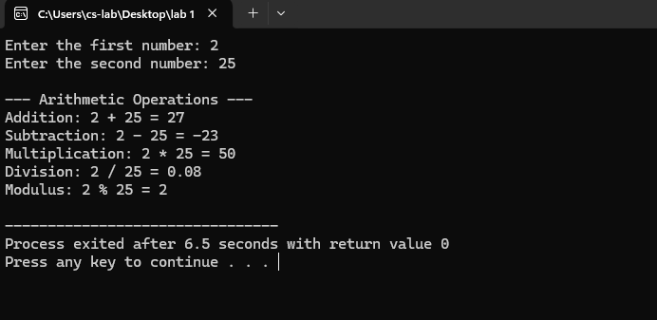
Write a C program to find the factorial of a given number using Functions
#include <stdio.h>
int fact(int n)
{
int f= 1;
for (int i =1; i <=n; i++)
{
f *= i;
return f;
}
}
int main()
{
int num;
printf("Enter a num: ");
scanf("%d", &num);
printf("Fact of %d = %d\n", num, fact(num));
return 0;
}
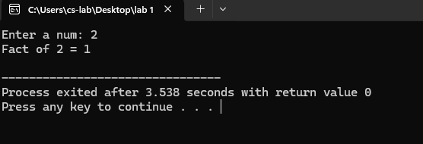

Write a C program to print the Fibonacci Series using Functions

#include <stdio.h>
void fibonacci(int n)
{
int a = 0, b = 1, c;
printf("Fibonacci Series: %d %d ", a, b);
for (int i = 2; i <n; i++)
{
c= a+b;
printf("%d ", c);
a = b;
b = c;
}
}
int main()
{
int n;
printf("Enter number of terms: ");
scanf("%d", &n);
fibonacci(n);
return 0;
}
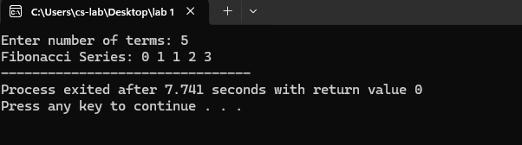
Write a C program to find the factorial of a given number using recursive Functions

#include <stdio.h>
int fact(int n)
{
if (n==0)
return 1;
else
return n * fact(n - 1);
}
int main()
{
int num;
printf("Enter a num: ");
scanf("%d", &num);
printf("Fact of %d = %d\n", num, fact(num));
return 0;
}
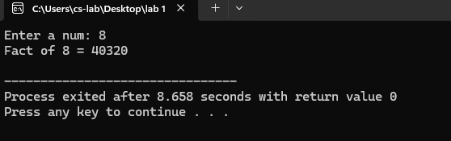
Write a C program to print the Fibonacci Series using recursive Functions
#include <stdio.h>
int fibo(int n)
{
if (n ==0) return 0;
else if (n== 1) return 1;
else return fibo(n - 1) + fibo(n - 2);
}
int main()
{
int n;
printf("Enter num of terms: ");
scanf("%d", &n);
printf("Fibo Series: ");
for (int i = 0; i <n; i++)
printf("%d ", fibo(i));
return 0;
}
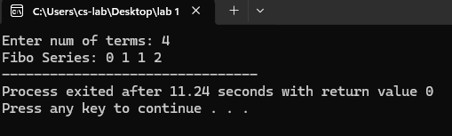
Write a C program to swap two numbers using Call by Value and Call by Reference

#include <stdio.h>
void swapByVal(int c, int d)
{
int temp = c;
c = d;
d = temp;
printf("After Swap (Call by Val): c = %d, d = %d\n", c, d);
}
void swapByRef(int *c, int *d)
{
int temp = *c;
*c = *d;
*d = temp;
}

int main()
{
int a, b;
printf("Enter two num: ");
scanf("%d %d", &a,&b);
printf("Before Swap: a = %d, b = %d\n",a,b);
swapByVal(a,b);
printf("After Call by Val: a = %d, b = %d (No change)\n",a,b);
swapByRef(&a,&b);
printf("After Call by Ref: a = %d,b= %d\n",a,b);
return 0;
}
